2020 IBSA GOALBALL
EUROPEAN CHAMPIONSHIPS
GROUP B

14th – 22nd of October 2020
AFULA

Information for Teams

Organization office

Israel Paralympic Committee
10, Shitrit St. Tel Aviv
Phone: +972 3 6493132
E-mail: israelgoalball2020@gmail.com

Main contact person for teams:

Ms. Limor Goldberg

Dates and General Information
IBSA Goalball European Championships 2020 Group B, Afula Israel will take place from the 14th to the 22nd of October 2020.
Competition Days: 17.-21.10.2020
Arrival: 14.10.2020
Departure: 22.10.2020

Travel information

Airports: Ben Gurion airport (TLV) https://www.iaa.gov.il

The LOC will organize logistics and cover all costs of transportation from the airport (mentioned above) to the official championships hotels on the 14th of October 2020. In Addition, the LOC will organize and cover all costs of transportation from the Official Championships Hotels back to the airport (mentioned above) on the 22nd of October. Cost coverage is only applicable to NPC delegation members.
Teams must provide information regarding travel arrangements by the dates requested on the booking forms.
All arrivals and departures outside the above dates must be coordinated with the LOC and paid for separately.

Passport and Visa

All visitors to Israel need a valid passport. Countries should contact their governing bodies or passport offices in order to get information specific to their region regarding traveling to Israel.
To check if you need a visa for entering Israel, you can follow this link:

https://www.gov.il/en/service/request_for_tourist_visa_b2

Regulations regarding Guide Dogs

If a team requires a guide dog, they should contact the tournament organizers at israelgoalball2020@gmail.com .

Shuttle in Afula

The LOC will organize and be responsible for transportation between hotels and competition venues.

ACCOMMODATION

1. Hotel Olive Gilboa
http://www.olivebb.com/doc/hotel-mountain-gilboa
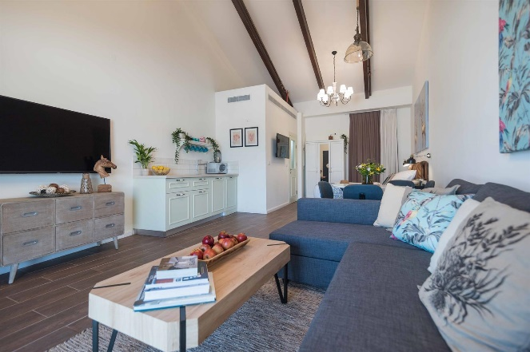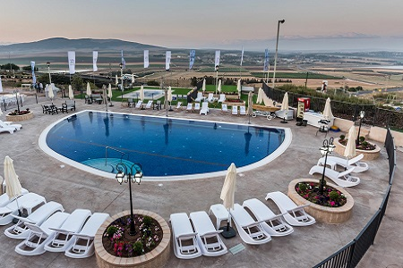
* Some rooms at the hotel are suites. Suites accommodate three people. (room size 40mr) – teams will be informed in advance of their room assignments

2. Hotel Nof Tavor
https://www.nof-tavor.com
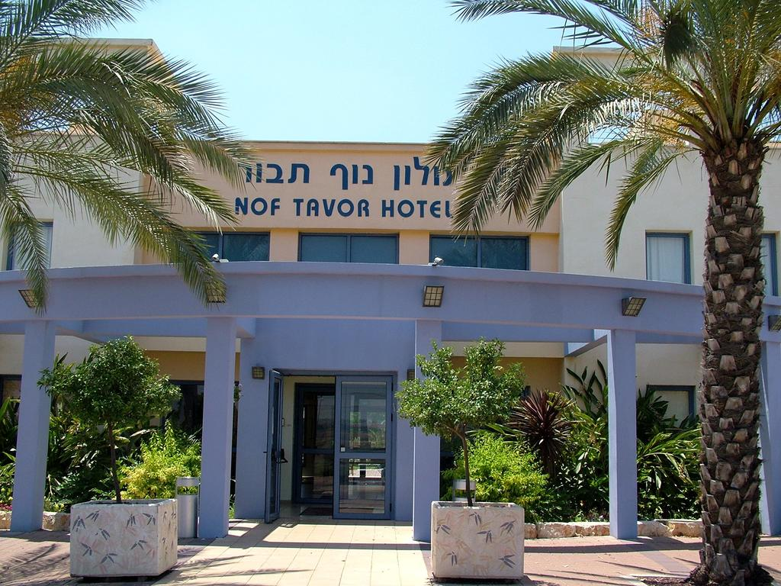
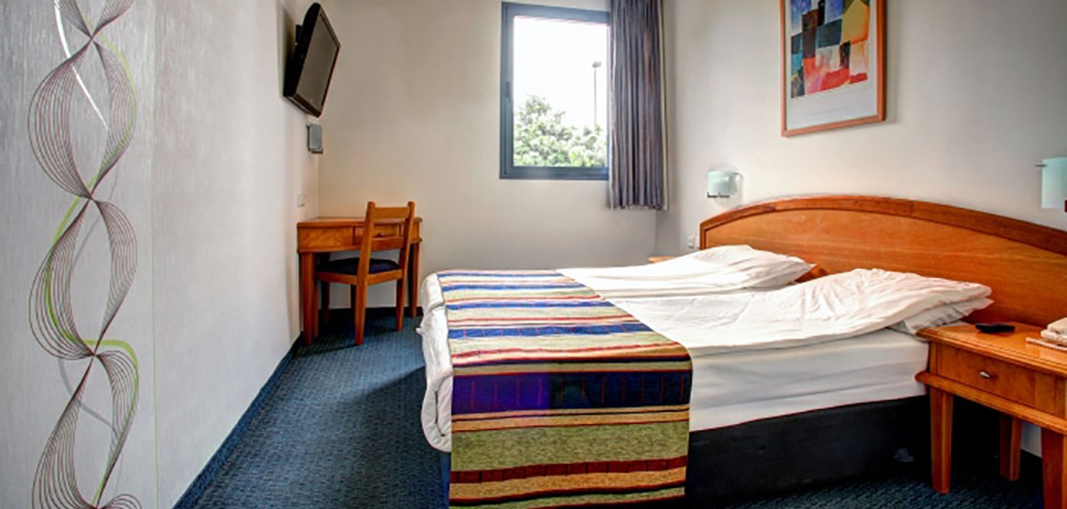
* The rooms are currently undergoing renovations

Catering

All accredited delegation members who have paid the Championships Competition Fee will be entitled to full board, breakfast and dinner in hotels and Lunch will served ‘lunch box’ style. Food accommodations will start with dinner on the 14th of October and end with breakfast on the 22nd of October, 2020.

Insurance

Each participating nation or its athletes/officials are in charge of getting their own health, accident and liability insurances prior to the competition dates.
Please make sure you have all relevant liability, accident and health insurance before leaving your country of origin.

Ball

The balls that will be used during the championships will be the German balls from KSG GmbH.

Doping Control

The event is subject to random doping testing in accordance with official IBSA regulations. Athletes should refer to the IBSA Anti-Doping Policy.
Any athlete taking medication subject to doping controls must be in possession of a valid IBSA Therapeutic Use Exemption (TUE). For information on IBSA’s anti-doping policies and how to apply for a TUE, go to http://www.ibsasport.org/anti-doping.

Classification

Classification process will respect IBSA procedure, as defined by IBSA Classification rules, http://www.ibsasport.org/documents/files/182-1-IBSA-Classification-rules-2018.pdf.
Only athletes competing in this event can be classified.
All athletes must be licensed for the current year.
Procedure for the classification of athletes at official competitions:
- A fully completed MDF form, dated and signed by a certified ophthalmologist, must be uploaded in ISAS by 02 September 2020. Only the current MDF (available for downloading from the IBSA website is accepted). http://www.ibsasport.org/documents/files/179-1-IBSA-Medical-Diagnostics-Form.pdf.
- For athletes with a Review status - tests and complementary medical exams requested in previous competitions should be uploaded at the same time as the MDF – by 02 September 2020. Every athlete should state in their MDF if they wear optical correction technology (glasses, contact lenses, filters) when they compete.
- Athletes without the correct MDF uploaded on time will not be scheduled for classification, and cannot enter the competition. There will be no exceptions.

VENUES and COMPETITION

Wizo Nir HaEmek Venue
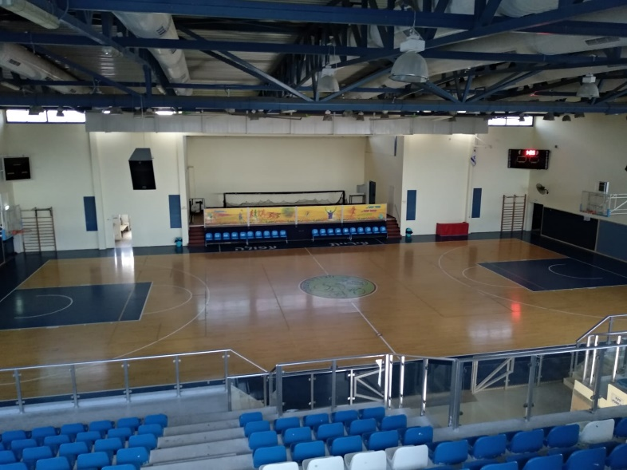
The main venue is Wizo Nir HaEmek Venue. The floor at the venue is of wooden.

AFULA Arena
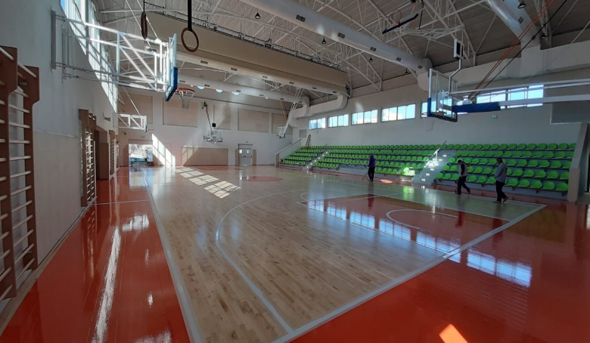
The floor at the venue will be wooden.

Training

Team training sessions will be organized on the official competition court. Each team will get one training session in both venues.

Referees and Rules

Referees will be official IBSA referees and all matches will be played according to the current IBSA Goalball Rules and Regulations.

OTHER INFORMATION

Athletes’ Eligibility
All the athletes must be licensed for the current year (2020), have a valid classification and be anIBSA Member in good standing.

Online registration with IBSA ISAS Database
Team athlete entries should be made using the ISAS Online Registration System: https://isas.ibsasport.org/isas/app/login 11.3 Athletes’.

COMPETITION SCHEDULE

Arrival of the teams: 14.10.2020
Classification Period: 14-16.10.2020
Training Period: 14-16.10.2020
Opening Ceremony: 16.10.2020
Competition Period: 17.-21.10.2020
Medal Ceremonies: 21.10.2020
Gala/Banquet: 21.10.2020
Departure: 22.10.2020

ENTRY FEE

For arrival on Wednesday, October 14th 2020 and departure Thursday, October 22nd 2020:
Entry fee: € 880 per person for the whole period for maximum six players and maximum three staff.
- Deposit (50%) to be paid by May 15th, 2020 (not refundable)
- Balance to be paid by August 15th, 2020
The fee coverage:
- Eight nights of accommodation from Wednesday, October 14th 2020 to Thursday, October 22nd 2020 (departure on 22th October) in double or triple rooms.
- Airport transfers to and from Ben Gurion airport
- Meals inclusive of dinner on Wednesday, October 14th 2020 until (and including) breakfast on Thursday, October 22nd 2020.
Single room accommodation for the entire period is subject to an additional charge of € 300, 00/person.

Additional costs

- IBSA capitation tax: €25/athlete
- Optional payment for extra nights:€150/person
- Arrival or departure outside of official times:€400/team
- Optional payment for additional group members: €1,200 per person

