APPLICATION FOR PARTICIPATION  Tokyo 2020 Men’s Final Paralympic Qualification Tournament  In cooperation with USA Volleyball, World ParaVolley is pleased to announce the staging of the Tokyo 2020 Men’s Final Paralympic Qualification Tournament, March 16-21, 2020. | 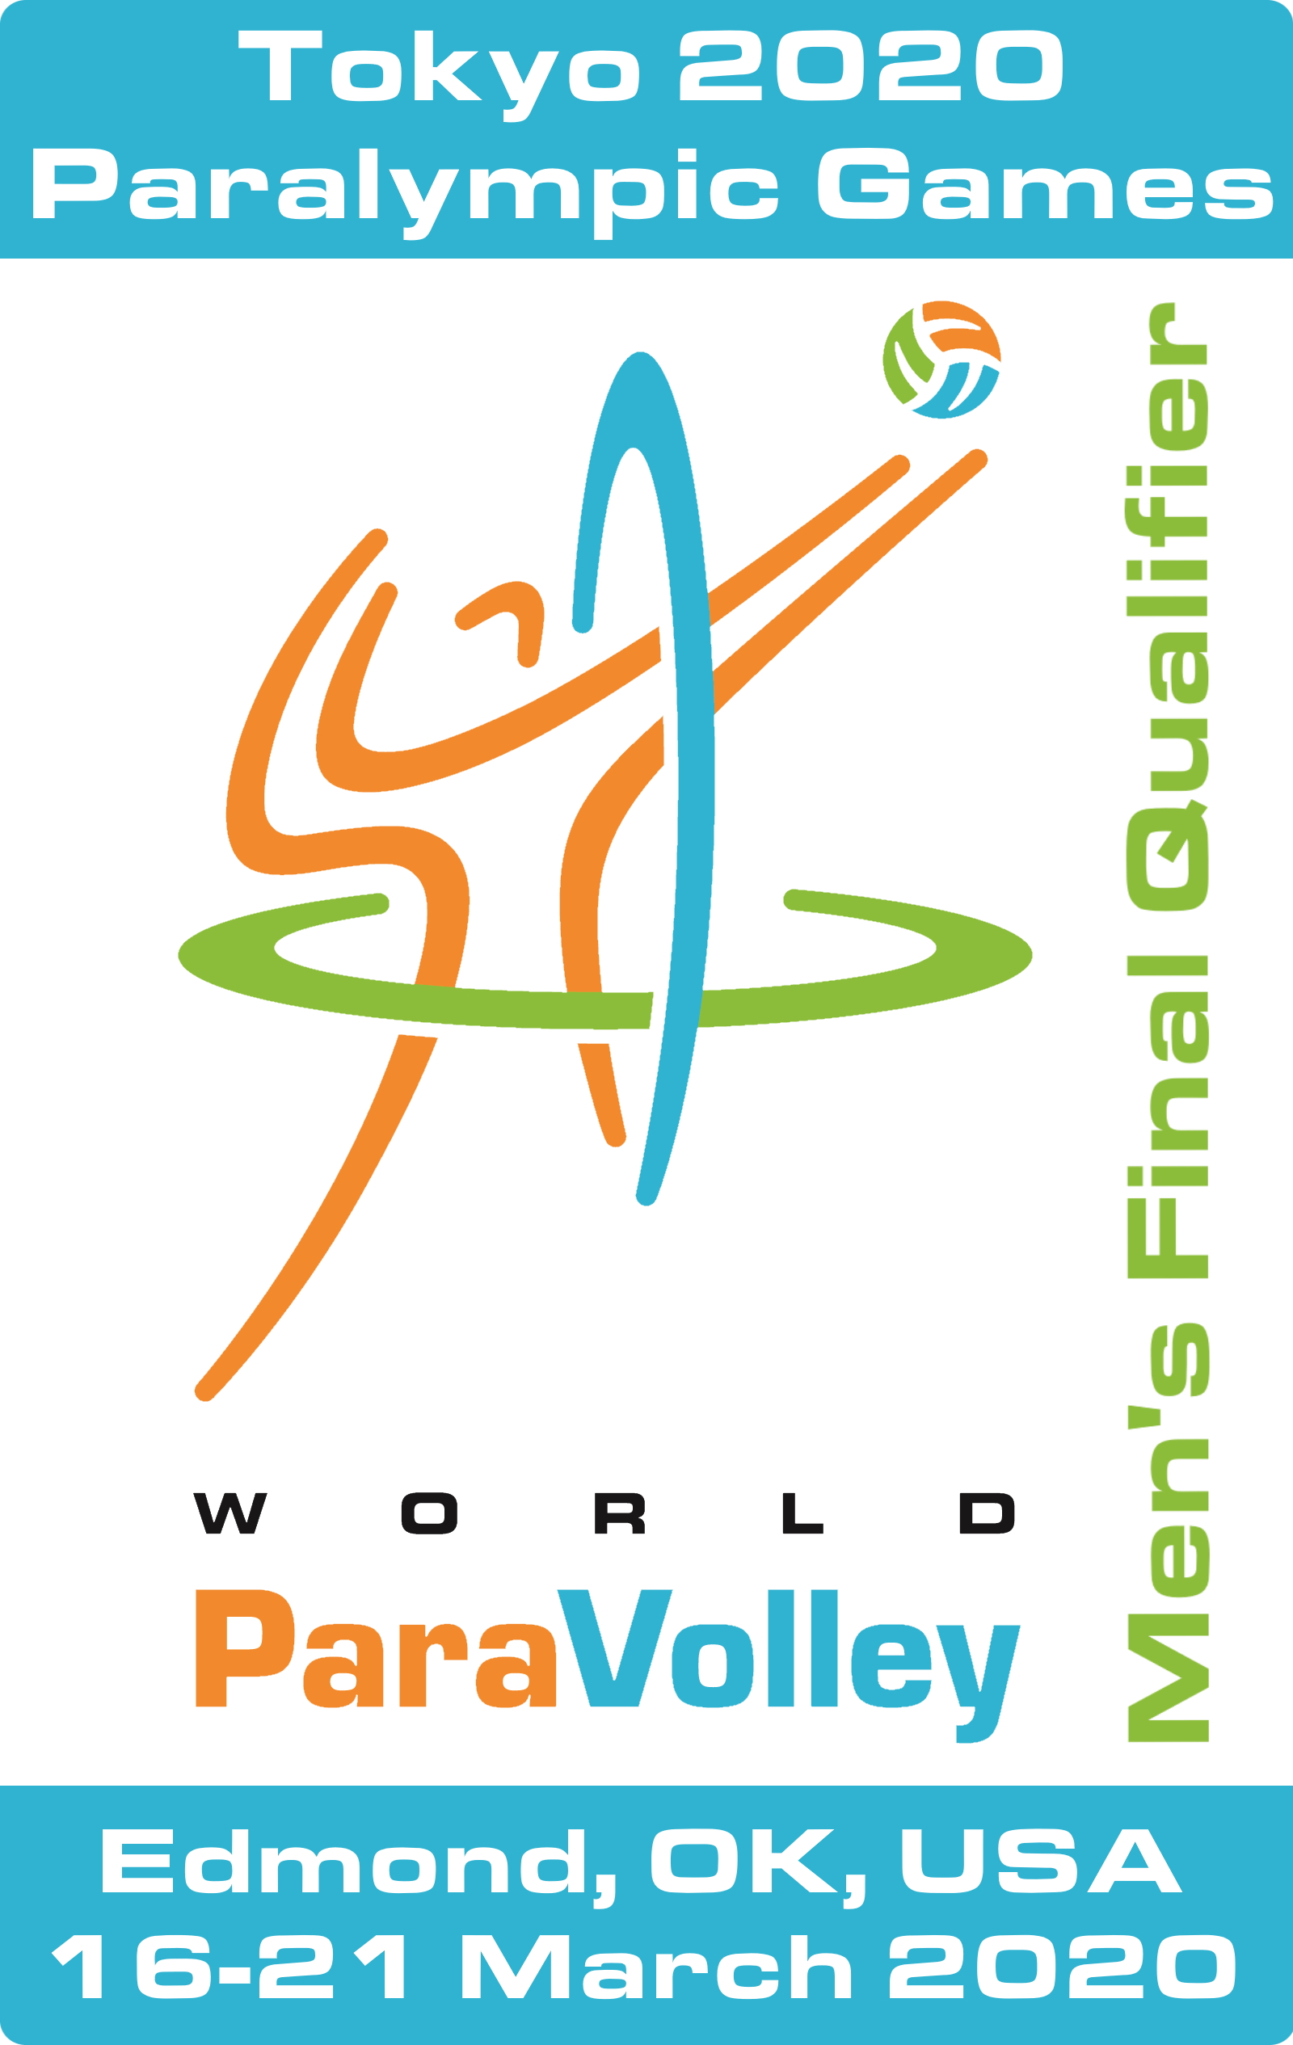

THE CONDITIONS

Competition
The team finishing in the Gold Medal position will gain the final qualification spot for the Tokyo 2020 Paralympic Games Men’s Sitting Volleyball Competition.

Where
- The Men’s Final Qualification Tournament will be held in the city of Edmond, Oklahoma, USA.
- Competition venue: University of Central Oklahoma Wellness Centre

When
- Competition dates: March 16-21, 2020
- Arrival date: March 13, 2020
- Departure date: March 22, 2020

Teams
The Men’s Final Qualification Tournament is NOT open to teams already qualified for the Tokyo 2020 Paralympic Games.

All teams from Member Nations (ranked AND unranked) in good standing not already qualified for the Tokyo 2020 Paralympic Games will be invited to complete this Application for Participation.

Selection of Teams
A minimum of two (2) teams must enter to validate the event. World ParaVolley and the LOC are planning for up to eight (8) teams. However, if more than eight (8) teams enter, World ParaVolley will negotiate this with the LOC to allow more teams.

The final participating team must submit the Final Team Entry Form containing up to twelve (12) players and five (5) bench personnel plus team manager and must pay the Team Entry Fee to World ParaVolley by January 10 2020 (This payment confirms your place in the event).

Classification
Classification will be available prior to the competition.

Team expenses
Participating teams are responsible for the following costs:
- National or international travel
- Travel insurance
- Medical insurance to cover hospitalisation and possible repatriation
- Visas — as applicable
- Team uniforms
- Food and accommodation (paid to the LOC)
- Refundable Security Fee in cash (paid to the LOC, if required by the LOC, but refundable)
- Administration fee (paid to the LOC)
- Team Entry Fee (paid to World ParaVolley)

Delegation size
- The maximum size for a Delegation is 18 persons unless otherwise agreed. The 18 persons are: 12 players, 1 Coach, 2 Assistant Coaches, 1 Doctor, 1 Therapist, and 1 Team Manager. Additional people may include media, friends, relatives and officials.

- Teams may nominate less than 18 persons in order to reduce their costs.

- If a team wishes to exceed the Delegation maximum number, the permission of World ParaVolley and the LOC must be obtained, and the board & lodging rates negotiated.

Delegation fees
- The LOC will charge the teams USD$175 per person per day for nine (9) days of food and accommodation (for twin rooms or triple room). If teams check out after 12:00 p.m. on March 22, teams will be responsible for making their own arrangements for hotel, accommodation, and ground transportation as well as being responsible for the associated costs.

- The LOC will charge the teams USD$225 per person per day for nine (9) days for food and accommodation (for single rooms). If teams check out after 12:00 p.m. on March 22, teams will be responsible for making their own arrangements for hotel, accommodation, and ground transportation as well as being responsible for the associated costs.

- The LOC will require each team to lodge a refundable Security Fee of up to USD $1,000 for security purposes.

- The LOC will require each team to pay an Administration Fee of USD $2,500 to cover items such as Anti-Doping, meeting and secretariat costs etc.

- World ParaVolley will charge each team a non-refundable €1,000 Entry Fee.

ENTRY VISAS – Special Note

Applicant Nations requiring Visas to enter the USA must communicate immediately with the LOC in order to work towards acquiring their entry Visas.

The LOC strongly encourages these nations to submit their visa applications no later than December 1st, 2019.

SUMMARY OF DEADLINES

Application for Participation | 10 November 2019
Visa applications submitted | 1 December 2019
- Final Team Entry Form  - World ParaVolley Entry Fee Payment | 10 January 2020

Please complete the following and submit by the deadline:

NATION:
WPV Member Federation:
We hereby apply to participate in the Tokyo 2020 Men’s Final Paralympic Qualification Tournament  Edmond, Oklahoma, USA  March 16-21, 2020  Yes No |  | EXPECTED NUMBER OF PARTICIPANTS  Athletes:  Bench Staff:  Other Personnel:
If we win the Tokyo 2020 Men’s Final Paralympic Qualification Tournament, we hereby confirm that we will accept the Nomination to compete at the Tokyo 2020 Paralympic Games.

Yes No
Contact person:
Contact email:
Contact phone:
Contact address:
City / State / Postal Code
President / Secretary General:  Name:  Signature:  Date: |  | Stamp:

Please submit this Application for Participation to:

generalmanager@worldparavolley.org

sportdirector@worldparavolley.org

elliot.blake@usav.org

DEADLINE: 10 November, 2019

